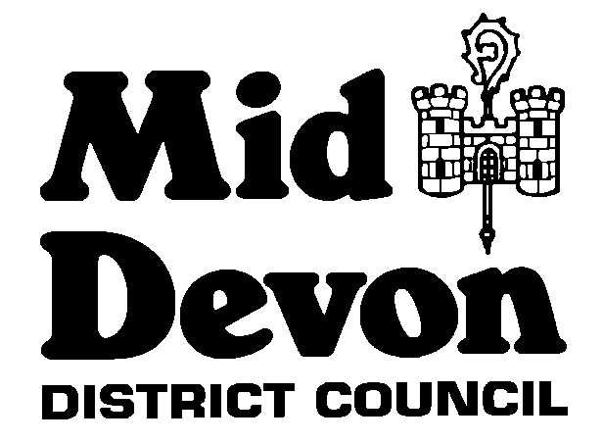

**MID DEVON DISTRICT COUNCIL**

**FOOD SAMPLING POLICY**

**1.0 INTRODUCTION**

1.1 Food authorities should prepare and publish a food sampling policy and make it available to businesses and consumers in accordance with the Food Standards Agency (FSA) Code of Practice and Guidance and to meet the standard laid down in the FSA Framework Agreement on Local Authority Food Law Enforcement.

1.2 This policy will set out Mid Devon District Council's (MDDC) general approach to food sampling and its approach in specific situations such as process monitoring, Home Authority principles, inspections, complaints, special investigations and national, regional and locally co-ordinated programme.

**2.0 FOOD SAMPLING - GENERAL**

2.1 Sampling makes an important contribution to the protection of public health and the food law enforcement function of the Local Authority. It is a useful tool for:

* Investigating complaints
* Investigating food poisoning or food contamination incidents
* Assisting in measuring compliance with food safety legislation when undertaking food hygiene inspections.

These matters are demand driven and samples will be taken as required.

2.2 Local Authorities have a duty to ensure food meet legally prescribed standards and routine sampling will monitor compliance.

2.3 MDDC will ensure appropriate action on non-compliance with food safety legislation is taken in accordance with the Food Safety legislation, Food Standards Agency Codes of Practice and the Enforcement Policy.

2.4 MDDC have a procedural document detailing the method for taking samples, continuity of evidence and preventing deterioration or damage to samples whilst under the Authority's control.

2.5 Samples for examination are sent by courier to UKHSA, Food Water and Environmental Microbiology Laboratory Porton Down, Salisbury, SP4 0JG. Samples for analysis are sent by courier to Public Analyst Scientific Services, i54 Business Park, Valiant Way, Wolverhampton, WV9 5GB. Other accredited laboratories may be used for specialist projects.

2.6 MDDC has been allocated credits by UKHSA for food sampling and the cost of additional samples for analysis or investigations can be covered from Public Health budgets.

**3.0 ROUTINE FOOD SAMPLING**

3.1 Routine sampling will be undertaken by Food competent Officers. Only Specialist Officers, Lead Officer and Team Leader, who are deemed competent in accordance with Code of Practice and Guidance will undertake formal food sampling.

3.2 MDDC have a sampling programme which has been devised in consultation with the UKHSA, Food Water and Environmental Microbiology Laboratory Porton Down to ensure routine samples are taken which reflect the needs of the area.

3.3 Intelligence from the Devon Food Sub-Group and Heart of the South West, Trading Standards will also be taken into account when developing the programme.

3.4 MDDC’s sampling programme will reflect the manufacturing, retail and catering premises within the district to ensure locally produced foods meet legal requirements and to assist those businesses in monitoring compliance. This will also reflect our Originating, Home Authority and Primary Authority responsibilities.

3.5 Mid Devon District Council will participate in UKHSA and local (Devon) co-ordinated sampling programmes with other Local Authorities.

3.6 Figures relating to food sampling undertaken by the Authority will be returned to the Food Standards Agency via the Food Surveillance System and LAEMS returns.

**4.0 FOLLOW-UP ACTION**

4.1 Following routine sampling, all results will be made available to the food producer/retailer/caterer at their request.

4.2 If borderline and/or unsatisfactory results are found the food producer/retailer/caterer must be notified of the results to discuss the proposed course of action.

4.3 If formal samples are taken in accordance with the FSA Code of Practice the local business will be notified and action taken in accordance with the Code of Practice and the Enforcement Policy in consultation with the Team Leader.

**5.0 REVIEW**

5.1 This policy will be reviewed to ensure it complies with FSA and other legal requirements.

5.2 The sampling programme will be reviewed and updated annually and as required to reflect local and national priorities.

Updated 20/06/2024 HS