

EMPLOYMENT LAND SURVEY

2011 to 2012

Contents | Page
- Introduction | 2
- Local Economy | 3
- Method | 4
- Employment Land Approvals | 5
- Employment Land Commitments | 6
- Employment Land Completions | 7
- Employment Land Under Construction | 9
- Allocated Employment Land | 10
- Employment Land Lost | 13
- Area Summary | 14
- Conclusion | 15

Appendix

Completions by site
Current Commitments by town
Under Construction by town

Contacts

- Introduction

1.1 The Employment Land Survey (ELS) monitors changes in employment land within Mid Devon.

1.2 However the ELS focuses on Classes B1 (Business), B2 (General Industrial) and B8 (Storage and Distribution). The National Planning Policy Framework (NPPF) defines economic development as including development “within the B Use Classes, public and community uses and main town centre uses (but excluding housing development).”

  - This ELS covers the period 1 April 2011 to 31 March 2012.

1.4 Why Monitor?

1.4.1 The Council is required to produce monitoring reports to review the progress of its local plans and supplementary planning documents, and the extent to which the policies in the documents are being achieved. The Allocations and Infrastructure Development Plan Document (AIDPD) sets out indicators and targets for this purpose.

1.5 Why Employment Land?

The NPPF requires that local planning authorities:

“plan proactively to meet the development needs of business and support an economy fit for the 21st century.”

“set criteria, or identify strategic sites, for local and inward investment to match the strategy and to meet anticipated needs over the plan period.”

“ensure that the Local Plan is based on adequate, up-to-date and relevant evidence about the economic, social and environmental characteristics and prospects of the area.”

1.5.2 The ELS gives information about land allocations for employment purposes, sites with planning permission, sites under construction and vacant land available for development.

1.5.3 By looking at the ELS, a record of economic trends within Mid Devon is provided, not only of land and premises which have been developed but also the updated situation on land that is likely to be developed in the near future.

1.5.4 In terms of policy there are a number of ways the local authority can use the monitoring information contained within the ELS. It allows the authority to identify changing priorities for development in regard to the policies and proposals set out within the Development Plan. Trends can be looked at against existing policies and targets to determine whether revisions to adopted policy documents might be needed.

    - The ELS forms part of the evidence base for the Local Development Framework (LDF) and the Annual Monitoring Report (AMR).

2. Local Economy

2.1 Overview
2.1.1 Mid Devon is an inland area covering 913 square kilometres in the South West of England. It is one of the most sparsely populated authorities within England and Wales, with a population of approximately 77,750 and where the majority of residents live in settlements below 3,000 population.
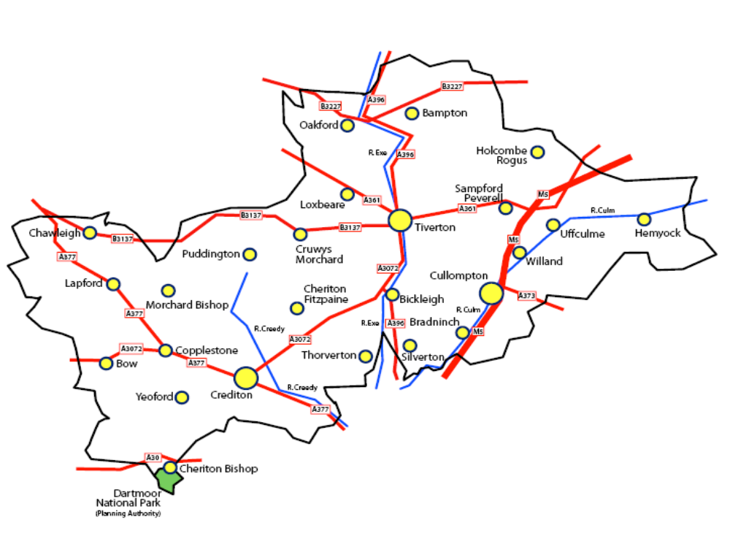
2.1.2 The main concentration of people is found in the eastern part of the District. Tiverton (population approx 22,000) is roughly central to the district, located about 11km (7 miles) from Junction 27 of the M5 and the Tiverton Parkway mainline railway station at Sampford Peverell. The M5 passes through Cullompton (population approx 8900) on its eastern side, with Junction 28 providing direct access to the town and the A373 running east towards Honiton. Crediton (population approx 7800) is the largest settlement in the west of the District, about 13km (8 miles) from Exeter. (Source of population figures: Devon County Council – PPSA Estimates rounded).

2.2 Employment Structure
2.2.1 The large and economically successful urban areas of Exeter and Taunton are just beyond the southern and eastern boundaries of the district respectively and exert an influence over the Mid Devon economy. For example, 16% of Mid Devon’s working population found employment in Exeter according to the 2001 Census. All three main towns have shown a reduction in people living and working in the same town over time.
2.2.2 Working at home was increasing in the district at the time of the 2001 Census, especially in the rural wards (20%). It is likely that this trend has continued with the expansion of broadband and increased travel costs. Up-to-date statistics will be reported when they become available.

2.2.3 Manufacturing is particularly important in Mid Devon accounting for 21.9% of jobs compared to 14.4% in the sub-region (source Exeter City Council: Economic Trends Report, August 2012). In Mid Devon there continues to be a large number of employees in agriculture and forestry and with the M5 route through Mid Devon, land transport is a major sector. National trends generally show a continued decline in these sectors, which could be a potential threat to employment in Mid Devon.

2.2.4 Small and very small businesses are important to the local economy. 80.5% of Mid Devon businesses employ 1-4 people (source ONS). Rural parts of the district show higher proportions still. 15% of the economically active population is self-employed (2011 Census) and historically the proportion has been comparatively higher in the rural areas (2001 Census).

2.2.5 Approximately 2.1 % of the district’s working population are claiming job seekers allowance (Official Labour Market Statistics 2012).

    - In the face of the current economic climate and the long term national decline in manufacturing the importance of an adequate supply of employment sites in addressing local economic need is clear.

3. Method

3.1 The period of monitoring for any particular year is between 1 April and 31 March. This ELS covers the period 1 April 2011 to 31 March 2012.

3.2 Information has been gathered on approvals, commitments, completions, sites under construction and employment land lost. This was achieved through a combination of desk-based assessment of planning history and site inspections. Staff in Development Management and Building Control also assisted in the process.

  - From 2008/09 all sites are included. Previously, sites were only taken into account if the new floorspace was over 100 sq.m.

3.4 For completions, the survey differentiates between individual Class B1, B2 and B8 applications. Changes of use applications between the use classes have not been included.

3.5 Development sites that involve the reuse of residential gardens are not considered ‘brownfield’.

4. Employment Land Approvals

4.1 Table one below provides a yearly comparison of employment land approvals over the past year. It includes applications that have also been started and completed between April 2011 and March 2012. The figures include only sites which provide additional employment land or floor area. They do not for example include approval of reserved matters on a site which already has outline consent.

4.2 The floorspace total includes extensions or new buildings within the curtilage of existing premises and industrial estates, however these are not included within the area total. Only sites with a known floorspace provision are included in this figure.

  - The area total includes outline applications.

Table 1 – Employment Land Approvals

Year  (1 April to 31 March) | Approval Area  (ha) | Floorspace  (sq.m.)
Between 1 April 2006  - 31 March 2007 | 7.57 | 6825.52
Between 1 April 2007  - 31 March 2008 | 1.10 | 11790
Between 1 April 2008  – 31 March 2009 | 7.3844 | 23853.70
Between 1 April 2009  – 31 March 2010 | 0.47 | 3807.89
Between 1 April 2010  – 31 March 2011 | 0.212 | 2144.47
Between 1 April 2011  - 31 March 2012 | 0.617 | 7838.25
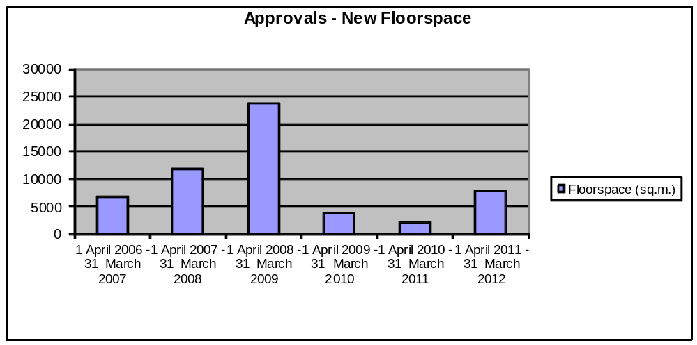

  - Over previous years the amount of employment floorspace being approved has remained quite consistent, with an average of around 7000 sq.m. Over the last five years this has risen to an average of 9,886.86 sq.m. This year 7838.25 sq.m. has been approved. This has increased on last year when only 2144.47 sq.m was approved. The floorspace in comparison to the hectares shows efficient use of land.

5. Employment Land Commitments

5.1 Table two indicates the total committed employment land for development for each year since 2006 i.e. land with a valid permission for employment use.

5.2 Included within Table 2 are approvals, previous years’ commitments that are still valid and outline permissions.

  - Excluded from Table 2 are local plan allocations without a current permission. Extensions or new buildings within the curtilage of existing premises and industrial estates are given a site area of 0ha.

Table 2 – Employment Land Commitments

Timeframe | Committed Area  (ha) | Floorspace  (m²)
At 31 March 2006 | 21.195
At 31 March 2007 | 28.453 | ( 86091.94 sq.m)
At 31 March 2008 | 29.062 | ( 86998.82 sq.m)
At 31 March 2009 | 32.6388 | ( 111382.15 sq.m)
At 31 March 2010 | 30.8418 | ( 105140.06 sq.m)
At 31 March 2011 | 29.2188 | ( 96204.53 sq.m)
At 31 March 2012 | 27.1208 | (95882.93 sq.m)

The floorspace showing in brackets in the above table includes both known floorspace figures and an assumed floorspace capacity on outline applications of 3500 sqm per hectare.

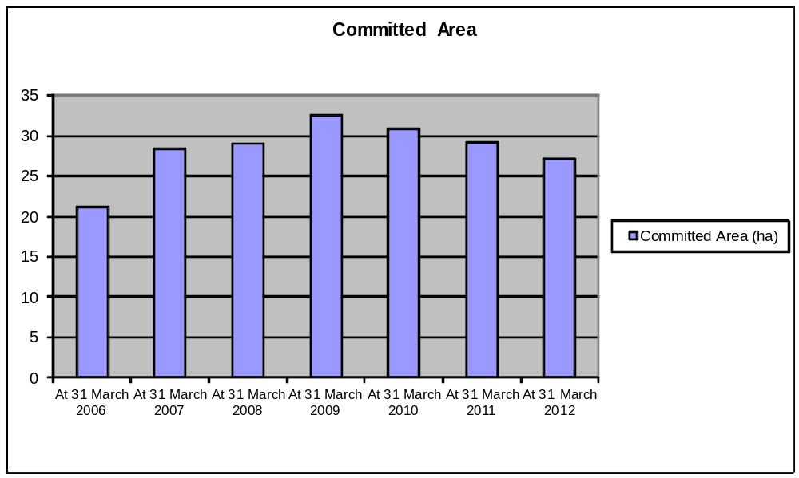

5.4 Between 2001 and 2005 there was a gradual increase in the hectarage of committed land in Mid Devon, indicating a small but steady replacement of stock. In the last six years a much greater increase has been influenced by the permissions for a 10.45 ha industrial estate at Willand and two permissions for 5.06 ha and 6.30 ha developments in Cullompton. The most recent figures show that commitments have dropped back slightly to just above the 2008 figure.

6. Employment Land Completions

6.1 Table three indicates employment completions or employment growth within a given year. It includes applications that have also been approved and started between April 2011 and March 2012.
6.2 The floorspace total includes extensions or new buildings within the curtilage of existing premises and industrial estates, however these are not included within the area total.

Table 3 – Employment Completions

Year  (1 April to 31 March) | Completed Area  (ha) | % Brownfield  (completed area (ha)) | Floorspace  (sq. m.) | % Brownfield  (completed floorspace)
Between 1 April 2006 – 31 March 2007 | 2.557 | 3.5 | 2044 | 42.6
Between 1 April 2007 – 31 March 2008 | 1.82 | 4.5 | 6854 | 54.5
Between 1 April 2008 – 31 March 2009 | 1.8172 | 20.36 | 6425.07 | 39.51
Between 1 April 2009 – 31 March 2010 | 0.345 | 76.8 | 6468 | 80.7
Between 1 April 2010 – 31 March 2011 | 0.9345 | 43.9 | 5458.65 | 57.03
Between 1 April 2011 – 31 March 2012 | 0.21 | 33.3 | 1839.6 | 79.9

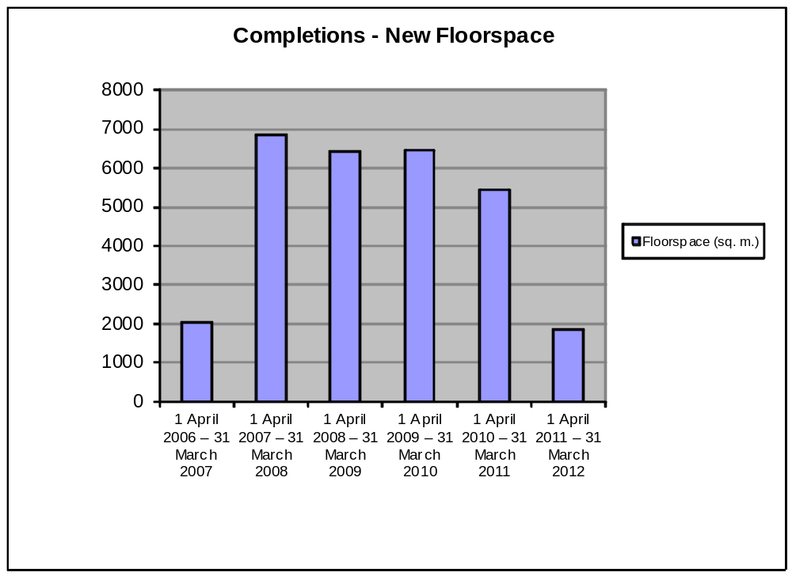

6.3 Building rates can be attributed to a number of factors, for example the overall health of the local economy, availability of employment land for development and form of tenure of the land.

6.4 This year (2011 to 2012) there were a total of 9 permissions that were completed, which is a decrease from the year before (2010 to 2011), where 16 were completed.

7. Employment Land Under Construction

7.1 By looking at Employment land under construction (Table 4), it can indicate how employment development is progressing and how it will develop over the coming year.

  - The floorspace total includes extensions or new buildings within the curtilage of existing premises and industrial estates. However these are not included within the area total.

Table 4 – Under Construction

Timeframe | Construction Area  (ha) | Floorspace  (sq.m.)
At 31 March 2006 | 4.312 | 4986.17
At 31 March 2007 | 2.844 | 6267.17
At 31 March 2008 | 1.615 | 6569.29
At 31 March 2009 | 1.4234 | 8453.67
At 31 March 2010 | 2.1814 | 8832.65
At 31 March 2011 | 2.2569 | 8047
At 31 March 2012 | 2.8389 | 9172.15

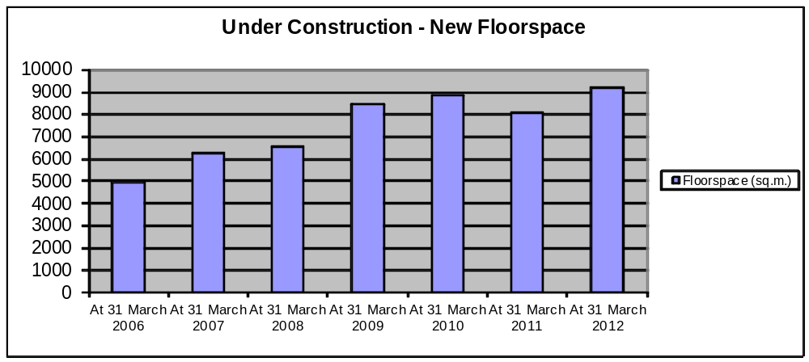

  - Floorspace under construction has increased steadily since 2001. This year both the construction area and the floorspace have slightly increased.

7.4 The increase in part reflected a number of things – the availability of land coming onto the market and then the time taken for this ‘availability’ to translate into under construction and ultimately completion.

8. Allocated Employment Land

8.1 The Council’s Development Plan (which provides the legal basis for planning decisions) sets out detailed employment policies, including specific employment proposals – which are subject to individual policies.

8.2 The adopted Core Strategy states that an additional 290,000 sq.m of employment land is required by 2026 at 14,700 sq.m per annum or above 4.2 ha per annum.

  - Between 1995 and 2001 7.05 ha of employment land was completed.

8.4 The Allocations and Infrastructure DPD (AIDPD) allocations shown below were based on the above guideline, as well as taking into account past developments and existing commitments.

8.5 Table 5 indicates the current position of employment land allocated by the
AIDPD which was adopted in October 2010.

Table 5 – Local Plan Allocations

Site | Location | Type | Policy | Total Area (ha) | Allocation remaining without permission at March 12. | Comment
Stone Crushing Works | Bampton | Brownfield | BA1 | 1.00 | 0.5 | Mixed Use Allocation site of 3.4 ha – residential and employment.  Reserved matters approved Jan 06. Work commenced Mar 07 on Phase 1 (0.5 ha) and it was completed in 07/08. Outline for Phase 2 Expired October 2009.
Bourchier Close | Bampton | Greenfield | AL/BA/2 | 1.1 | 1.1 | Mixed Use Allocation Site (Housing & Employment). Whole Site 2.4 ha, 1.3 ha Housing,  1.1 ha / 4000 sq.m Employment.
South Of Iter Cross | Bow | Greenfield | AL/BO/2 | 0.5 | 0.5 | Allocation of  0.5 ha / 7000 sq.m for Employment Development.
South West Of Junction Road | Bow | Greenfield | AL/BO/3 | 0.6 | 0.6 | Allocation of  0.6 ha / 2100 sq.m  For Employment Development.
South East Of Village Hall | Kentisbeare | Greenfield | AL/KE/1 | 0.14 | 0.14 | Mixed Use Allocation Site (Housing & Employment) Whole Site 0.8 ha, 0.66 ha Housing, 0.14 ha / 500 sq.m Employment.
Mill Street  (Bow Belle) | Crediton | Brownfield | CRE5 | 0.5 | 0.5 | 50% of 1 ha site is also for housing.  Outline approved March 04  and it Expired March 2009. Housing all fully completed in 09/10.
Wellparks | Crediton | Brownfield | AL/CRE/7 | 1.5 | 1.5 | Allocation of  1.5 ha / 4150 sq.m  For Employment Development.
North West Cullompton | Cullompton | Greenfield | AL/CU/1 | 11.4 | 11.4 | Mixed Use Allocation Site (Housing & Employment) Whole Site 74.8ha,  63.4 ha Housing,  11.4ha/40000sq.m  Employment.
Week Farm | Cullompton | Greenfield | AL/CU/13 | 10.5 | 10.5 | Allocation of  10.5ha/15000 sq.m  For Employment Development.
Eastern Urban Extension | Tiverton | Greenfield | AL/TIV/1 | 27.1 | 27.1 | Mixed Use Site (Housing/Employment/ Retail & Leisure). Whole Site 153 ha. Employment 27.1 ha / 112,500 sq.m which reflects median of range of employment for site (95,000 – 130,000).
Blundells School | Tiverton | Brownfield | AL/TIV/9 | 2.00 | 2.00 | Mixed Use Allocation Site (Housing & Employment) Whole Site 14 ha, 12 ha Housing, 2 ha Employment @ 35% plot ratio (7000 sq.m).
William Street | Tiverton | Brownfield | AL/TIV/13 | 0.01 | 0 | Mixed Use Allocation Site 0.9 ha (0.88 ha Housing, 0.01 ha Employment, 0.01 ha Retail). Full permission granted Dec. 09.
South View Rd | Willand | Greenfield | WI1 | 10.45 | 0 | Outline approved Dec.05. Reserved matters approved Nov.07 for part of Phase 1 - 0.42 ha and it was completed 08/09. Another part of Phase 1 - 0.29 ha approved Mar. 09. This Commenced 09/10 and Completed in 10/11.

9. Employment Land Lost

9.1 Table 6 details the loss of employment land between 1 April 2011 to 31 March 2012.

Table 6 – Employment Land Lost

Site | Location | Area (ha) | Reason | Use Class Lost
Manor Rooms, Newton Square | Bampton | 0.00ha | Residential | B1a
Claremont, 65 Fore Street | Cullompton | 0.00ha | Residential | B1a
5 High Street | Cullompton | 0.00ha | Residential | B1a
18 High Street | Cullompton | 0.006ha | Residential | B1a
46 St Peter Street | Tiverton | 0.01ha | Residential | B1a
Bramber Boat Trailers Ltd. South View Road | Willand | 0.09ha | Sui Generis | B1c
 |  | Total: 0.106ha

9.1 The loss of employment land has slightly decreased from 0.138ha for 10-11 to 0.106ha for 11-12. Any loss of employment land can be attributed to a number of factors for example lack of demand in the future for that employment use, site constraints and increased demand for other uses e.g. residential, retail. Losses of employment land continue to be small, indicating strong demand and a protective policy approach in recent years.

10. Area Summary

10.1 Table 7 shows the ‘urban’/’rural’ picture within Mid Devon with regards employment land development.

Table 7 – Area Summary

Area | Commitment  (At 31 March 2012)  sq.m. below includes assumed floorspace on outline applications (3500 sqm per ha)  (ha) (sq.m.) |  | Approvals  (Between 1 April 2011 – 31 March 2012)  (ha) (sq..m.) |  | Under Construction  (At 31 March 2012)  (ha) (sq.m.) |  | Completed  (Between 1 April 2011– 31 March 2012)  (ha) (sq.m.) |  | Other
Rural Parishes | 11.5598 | 42100.28 | 0.22 | 2761 | 2.6789 | 7226.02 | 0.20 | 1163.6 | 6 Local Plan Allocations totalling 13.79 ha. The allocation at Willand has two small parts completed, and the remainder with outline permission. Bampton is half completed, the rest remains without permission. Currently a site in Bampton, two sites in Bow and a site in Kentisbeare have no planning permission.
Urban  (Crediton, Cullompton and Tiverton) | 15.561 | 53782.65 | 0.397 | 5077.25 | 0.16 | 1946.13 | 0.01 | 676 | 7 Local Plan Allocations totalling 53.01 ha. 1 allocation at Tiverton has an approved application. The remaining six sites currently have no planning permission.

10.2 Last year (10-11) there was slightly more committed land in both the urban and rural areas. This year (11-12) this remains the same. There are more approvals in both areas, also more under construction in both areas. Completions during 11-12 are down in both areas.

10.3 The urban areas (ha) are larger than those in the rural areas for commitments, and approvals. However the rural areas (ha) are higher for those under construction and for completions.

11. Conclusion

11.1 The percentage of approvals, sites under construction and completions on brownfield sites is fairly erratic, however Mid Devon is a rural district and therefore it should be recognised that there is only a limited supply of brownfield land available at any one time. Also there is often pressure for non-employment uses, for example residential or retail when such sites become available for redevelopment.

11.2 There tends to be a lot more greenfield developments in Mid Devon i.e. conversions of agricultural buildings to employment use, as there is diversification away from traditional farming.

11.3 A lot of employment development within Mid Devon is in the form of extensions to existing buildings or new buildings within the curtilage of an existing building therefore the area (ha) figure can look fairly low.

11.4 The increases in floorspace along with the smaller area totals are a good indication that employment land is being developed on already existing sites.

11.5 Looking forward into the next year (April 2012 to March 2013) there have been increases in the number of approvals and sites under construction. However decreases in commitments and completions. Allocated sites are higher than in previous years as the Allocations and Infrastructure Development Plan Document was adopted in October 2010.

11.6 The slower development of new employment floorspace provision relates to the change in the current economic climate. Large sites are currently not coming forward but hopes are that growth will recommence soon. The fact that any additional output is in both rural and urban areas is a positive sign for all areas of the district. It is expected that Masterplanning of large mixed use allocations in the AIDPD will occur during 2013.

Completions by site 1 April 2011 to 31 March 2012

Site | Use Class | Greenfield/Brownfield | Completed Area  (ha) | New Floorspace  (sq.m.)
Bampton
Manor Rooms | B1a | B | 0.00 | 17.5
 |  |  | Total: 0.00 | Total: 17.5
Crediton
SW Galvanisers Ltd | B8 | B | 0.00 | 147
 |  |  | Total: 0.00 | Total: 147
Cullompton
 |  |  | - | -
 |  |  | Total: 0.00 | Total: 0.00
Tiverton
Trade South West | B1c | B | 0.01 | 529
 |  |  | Total: 0.01 | Total: 529
Elsewhere
Town Farm, Burlescombe | B8 | B | 0.01 | 75
Coddiford,  Cheriton Fitzpaine | B1a | G | 0.01 | 164
Yeo Vale Industrial Estate, Lapford | B2 | B | 0.01 | 226
Hele Farm,  Nymet Rowland | B1a | G | 0.13 | 206
Wedgewood Buildings Ltd. Oakford | B2/B8 | B | 0.03 | 315.1
Tridley Foot Hill,  Woolfardisworthy | B1a/c | B | 0.01 | 160
 |  |  | Total: 0.20 | Total: 1146.1
 |  |  | Total: 0.21 | Total: 1839.6

Current Commitments By Town As At 31st March 2012

Site | Greenfield/Brownfield | Area  (ha) | New Floorspace  (sq.m.)  Floorspace shown in brackets is assumed floorspace on outline applications of 3500 sq.m. per ha.
Bampton
 |  | - | -
 |  | Total: 0.00 | Total: 0.00
Crediton
Exeter Road | G | 3.0 | 9050
Commonmarsh Lane | B | 0.02 | 240
Creative Furniture | B | 0.02 | 213
 |  | Total: 3.04 | Total: 9503
Cullompton
Week Farm | G | 5.06 | 14178
Old Station Yard | B | 0.22 | 1018
South Of Kingsmill Road | G | 6.304 | (22064)
Kings Mill Road | B | 0.3 | 1300
Double S Exhausts Ltd | B | 0.00 | 170
Pumping Station | B | 0.02 | 150
Higher Kings Mill Ltd | B | 0.33 | 3398
 |  | Total: 12.234 | Total: 42278
Tiverton
Former Tiverton Hospital | B | 0.01 | 762.4
Tiverton Fabrications | B | 0.00 | 412
Lowman Green | B | 0.27 | 501
Brooklands (Unit 9) | B | 0.00 | 202
Oxfam, 10 Fore Street | B | 0.007 | 79.25
Brooklands (Unit 7) | B | 0.00 | 45
 |  | Total: 0.287 | Total: 2001.65
Elsewhere
Maidendown Stage, Burlescombe | B | 1.14 | 3129
Maidendown Stage, Burlescombe | B | 0.00 | 299.4
Jersey Farm, Burlescombe | G | 0.12 | 1175
White Cross Farm,  Cheriton Fitzpaine | B | 0.02 | 169
Acre Ridge, Clayhidon | B | 0.05 | 216
Courtneys Garage, Copplestone | B | 0.01 | 29.08
Middle Hollacombe,  Crediton Hamlets | G | 0.034 | 291
Chapel Downs,  Crediton Hamlets | G | 0.10 | 527
Pennymoor Timber,  Cruwys Morchard | B | 0.00 | 559.3
Rowridge Farm, Halberton | G | 0.005 | 74
Pitt Farm, Halberton | B | 0.01 | 108
Hitchcocks Farm, Halberton | B | 0.04 | 473
Former St Ivel Factory Site,  Hemyock | B | 0.27 | 512.5
Unit 6, Station Road,  Hemyock | B | 0.00 | 145
Exmoor Stoves, Morebath | B | 0.03 | 336
Industrial Estate, Willand | G | 9.7308 | (34057)
 |  | Total: 11.5598 | Total: 42100.28
 |  | Total: 27.1208 | Total: 95882.93

Under Construction By Town As At 31st March 2012

Site | Greenfield/Brownfield | Area  (ha) | New Floorspace  (sq.m.)
Bampton
 |  | - | -
 |  | Total: 0.00 | Total: 0.00
Crediton
Fordton | B | 0.10 | 1074
Page Partners LLP | G | 0.00 | 230
 |  | Total: 0.10 | Total: 1304
Cullompton
Aller Barton Farm | B | 0.05 | 465.13
 |  | Total: 0.05 | Total: 465.13
Tiverton
Norwood Farm | B | 0.01 | 150
O & B Vehicle Solutions | B | 0.00 | 27
 |  | Total: 0.01 | Total: 177
Elsewhere
Lower Brithayes, Bickleigh | G | 0.01 | 150
Maidendown Stage, Burlescombe | B | 0.42 | 1194
Mounson Farm, Cheriton Bishop | B | 0.21 | 694.75
West Upham Farm,  Cheriton Fitzpaine | G | 0.03 | 350
Gollick Park, Clayhidon | G | 0.11 | 128
Higher Elston, Copplestone | G | 0.02 | 197
Sellake Barn, Halberton | G | 0.01 | 105
Culmbridge Farm, Hemyock | G | 0.30 | 204
Shuttleton Farm, Hemyock | G | 0.01 | 144
Old Ridgewood Farm, Hemyock | G | 0.02 | 197
Upper Whitemoor, Hemyock | G | 0.01 | 81
Greenham Ind. Estate,  Holcombe Rogus | B | 0.47 | 973
Kytton Barton, Holcombe Rogus | G | 0.01 | 100
Long Drag, Kentisbeare | G | 0.08 | 150
Westhayes, Kentisbeare | G | 0.15 | 187
East Of Higher Pirzwell, Kentisbeare | B | 0.03 | 355
Lapford MOT & Service Station | B | 0.00 | 65.10
Royal Oak House, Loxbeare | B | 0.01 | 50
Meadowside Garage, Sandford | B | 0.062 | 88.17
Moor Farm, Shobrooke | B | 0.14 | 120
Down Farm, Stockleigh English | G | 0.0069 | 54
Thorverton Mill | B | 0.53 | 1302
Court Barton, Thorverton | G | 0.02 | 167
Higher Pitt Farm, Washfield | B | 0.02 | 170
 |  | Total: 2.6789 | Total: 7226.02
 |  | Total: 2.8389 | Total: 9172.15

Contacts

If you have any questions about this survey please contact:

Janet Crook
Forward Planning & Conservation
Phoenix House
Phoenix Lane
Tiverton
EX16 6PP

Tel: 01884 234360

Email: jcrook@middevon.gov.uk

