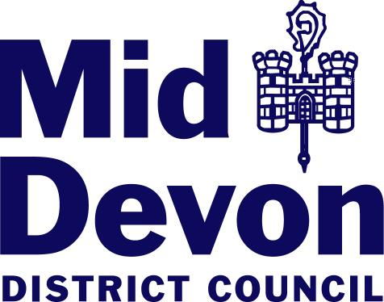

Rural Services in Mid Devon 2010

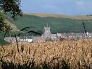

Contents

- Introduction
- Method
- Doctor
- Library
- School
- Shop
- Pub
- Hall
- Post Office
- Bus Service
- Petrol Station
- Summary

Contacts

Annexe – Data used in survey

1. Introduction
1.1 Mid Devon is one of the most sparsely populated authorities in England and Wales. The majority of residents live in settlements below 3,000 in population.
The rural nature of the authority means that creating “thriving, inclusive and locally distinctive communities “ (source: PPS4) is vital.

1.2 Planning Policy Statement (PPS) 1 – States that planning authorities should ensure that infrastructure and services are provided to support new and existing economic development and housing.

1.3 As “Review and monitoring are key aspects of the Government’s ‘plan, monitor and manage’ approach to the planning system.” (source: PPS12), it is important to monitor the level of services in rural communities in Mid Devon.

2. Method

2.1 In total 55 settlements were selected:
21 villages (as designated by the submitted Core Strategy): Bow, Bradninch, Burlescombe, Chawleigh, Cheriton Bishop, Cheriton Fitzpaine, Copplestone, Culmstock, Halberton, Hemyock, Kentisbeare, Lapford, Morchard Bishop, Newton St Cyres, Sampford Peverell, Sandford, Silverton, Thorverton, Uffculme, Willand and Yeoford
34 smaller settlements from parishes that did not have a village or market centre: Bickleigh, Brushford, Butterleigh, Cadbury, Cadeleigh, Clayhanger, Clayhidon, Coldridge, Colebrooke, Cruwys Morchard, Down St Mary, Hittisleigh, Hockworthy, Holcombe Rogus, Huntsham, Kennerleigh, Loxbeare, Morebath, Nymet Rowland, Oakford, Poughill, Puddington, Shobrooke, Stockleigh English, Stockleigh Pomeroy, Stoodleigh, Templeton, Uplowman, Upton Hellions, Washfield, Washford Pyne, Wembworthy, Woolfardisworthy, Zeal Monachorum

2.2 A range of services and facilities was drawn up to check at the selected villages and settlements above. These included Doctor, library, school, shop, pub, hall, Post Office, bus service and petrol station.

2.3 The results were achieved through a combination of site inspections and of desk-based assessment of official websites e.g. Devon County Council, NHS, Post Office.

  - Each service or facility was analysed pictorially as a whole for all the villages and all the other settlements. Any changes have been noted otherwise services or facilities remain the same as the previous year.
3. Doctor 

The NHS was set up to provide healthcare for all citizens, based on need. It can be seen below that many communitites in rural areas do not have comprehensive provision.

Villages Other Settlements

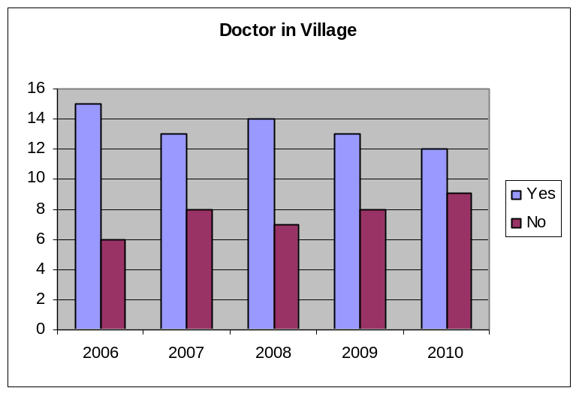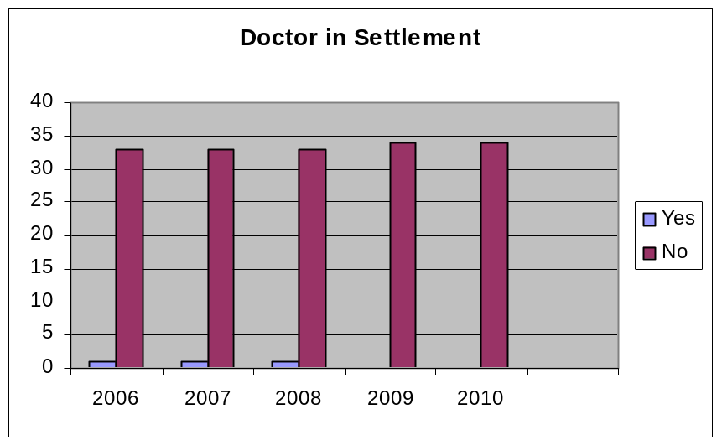

Three of the twelve villages that had a doctor had a “Branch surgery”, therefore offering limited surgery times and services.
A branch surgery is very often a subsidiary service to a main surgery, based in a particular location e.g. village hall or a mobile service. Since
2009 Kentisbeare has lost its Branch Surgery.
Within the NHS there is a move towards centralisation and reduced provision of healthcare services to small communities. It means that some certain groups within rural communities e.g. the elderly or young people find it difficult to access the healthcare that they need.
When looking at rural healthcare provision it needs to be remembered that there are differences from healthcare in other areas. For example a doctor in a rural area will often need a larger range of clinical skills and may experience difficulties associated with distance and travel.
4. Library 

The public library is a unique institution, which aims to meet the information needs of the public, stimulate and enrich people's experience of imaginative and creative work and support people's formal and informal educational requirements.

Villages Other Settlements

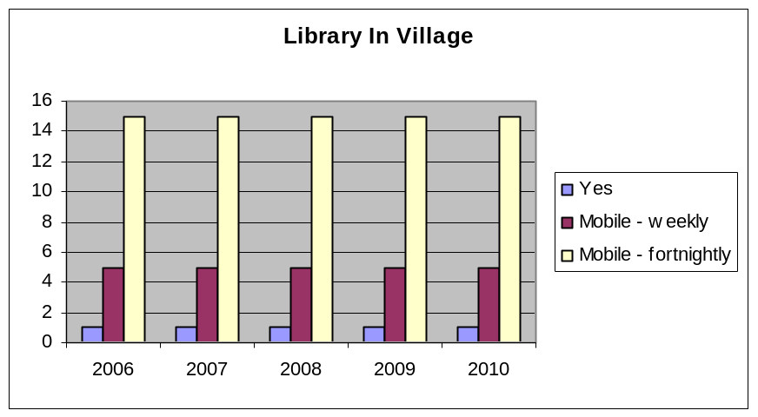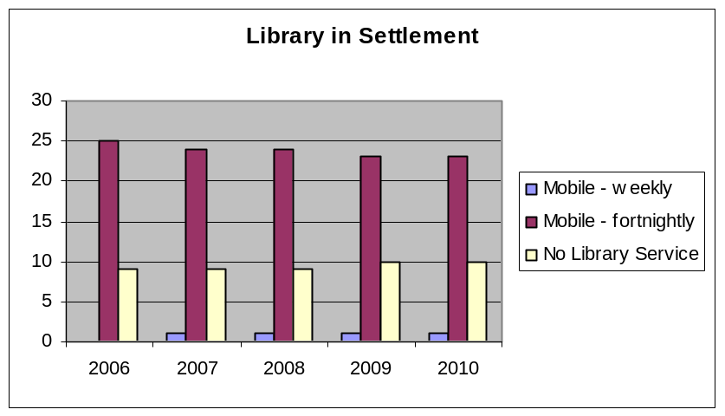
Uffculme is the only one of the settlements selected to actually have a library, all the other settlements, apart from 10, are served by some sort of mobile library service.
A mobile library service brings a town service to isolated rural settlements and communities and very often the library van visits hard to reach places, where there is not even a bus service e.g. Butterleigh, Loxbeare.
In many the mobile library visit is the only remaining public service and in being so are able to enrich rural life and help to overcome isolation by providing library and information services in new and imaginative ways.

5. School 

A school can be an important element of a thriving village.

Villages Other Settlements
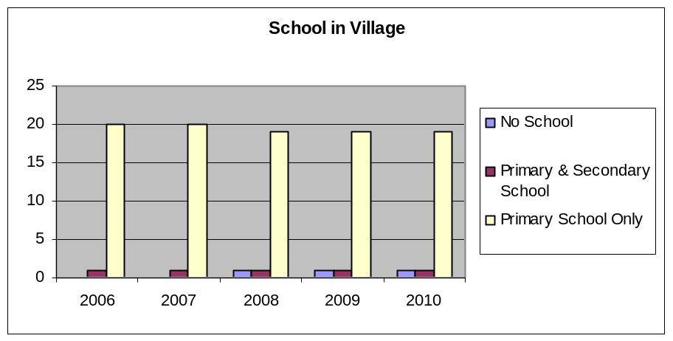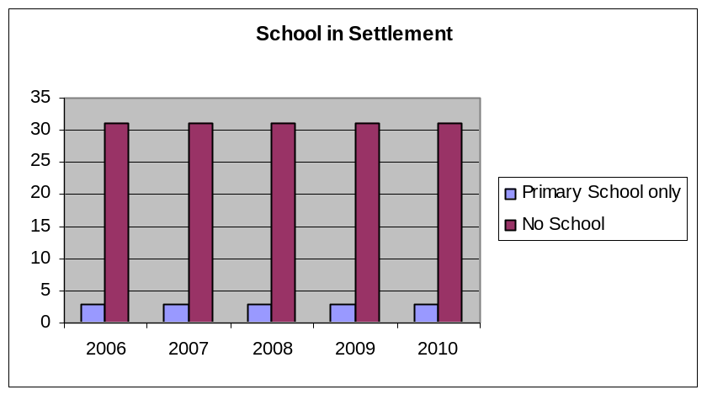

Unfortunately schools in rural areas are increasingly coming under more pressure. Within Mid Devon Chawleigh school officially closed at the end of August 2007, as the number of pupils had declined. Also within Mid Devon other village schools may come under threat of closure if their number of pupils decline.
The above graph shows all of the defined villages had a primary school until Chawleigh school officially closed in August 2007. Of the remaining settlements only 3 have schools ( Bickleigh, Holcombe Rogus and Uplowman).
There are many benefits of rural schools including: Children are educated closer to home and the curriculum can be directly related to the local environment. There is easy accessibility for parents and teachers alike, the rural village primary school may also play a key role in the social, as well as educational life of the community and it may provide a rich cultural resource for the village and be a focus for a range of activities. A balance has to be struck between the difficulties and increased costs of maintaining a very small school and the consequences of its closure for young children, particularly in terms of travelling times.

6. Shop 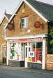

Village shops play a vital role in community social cohesion and as a local information centre

Villages Other Settlements

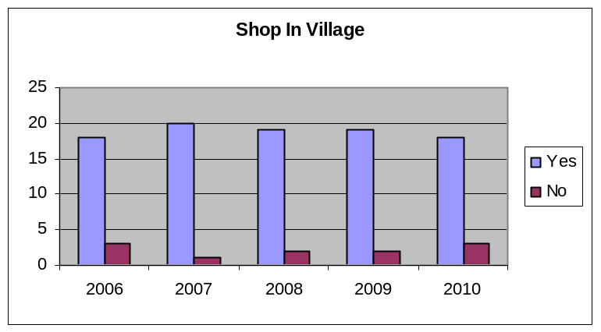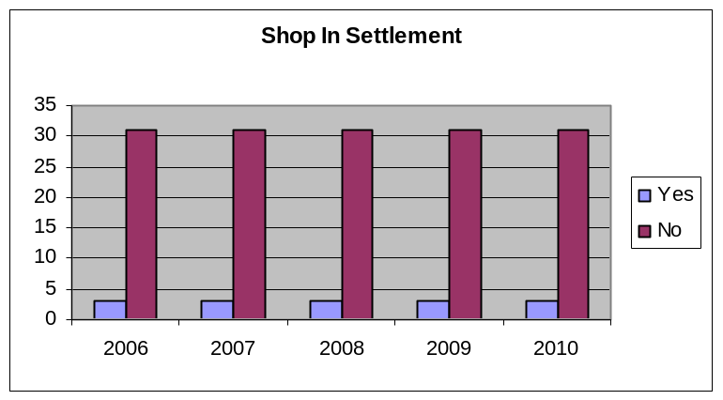

As can be seen above the majority of the villages have a shop - a lot are also combined with the Post Office – partly because since supermarkets have come about it has been a case of adapt or die. The majority of the smaller settlements do not have one.

It has been increasingly difficult for villages and smaller settlements to maintain their local shop services in the face of increasing trading pressures from larger supermarket chains and from the adverse impacts of wide ranging changes in the patterns of demographics, transport and lifestyles in rural communities. For example Thorverton – had a shop up until April 2006. Through community action the person running the post office bought a disused mobile library and has now opened this up as a village store next to the Post Office within the village car park.

Since 2009 Chawleigh’s Post Office and separate shop have both closed. A new purpose built building is currently under construction which will contain a shop and Post Office facilities.

Village shops are needed for a variety of reasons - non-mobile people, in particular the elderly, really need them, a local shop ups the value of your property by a considerable amount, it will save you time, effort and travelling money and finally one of the most important reasons for having a village shop - is that it is a centre for the community. People are in and out all the time: we know what's going on, who needs help, who's done something exciting, and so on - and newcomers to the village can get to know people just by shopping. Without it, people have less reason for being out and about - and you could go for days without seeing anyone.

7. Pub 

The pub is often the main or only focus of community life in rural areas. It has been given royal approval as the heart of village life (see below)

“Rural communities, and this country’s way of life, are facing unprecedented challenges ……the country pub, which has been at the heart of village life for centuries, is disappearing in many areas.
By providing new services from the pub, such as a post office or a shop, not only keeps an essential service in the village or brings one in, but increases the income of the pub itself, giving it a more secure future. “HRH Prince Charles

Villages

Other Settlements

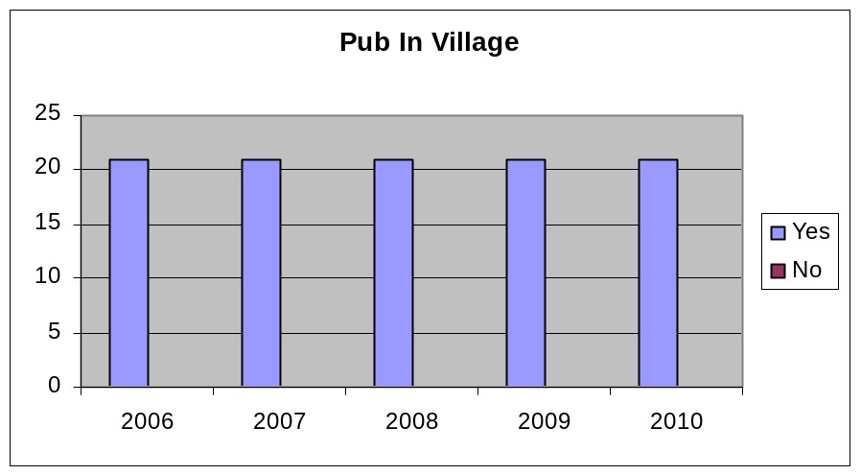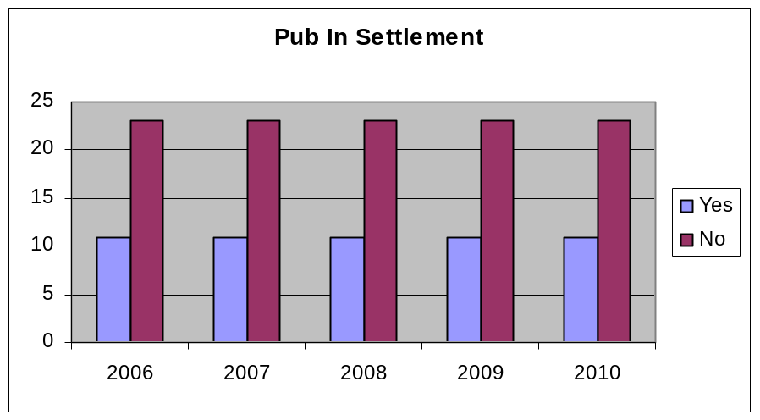

Even the smallest places can have a pub e.g. Butterleigh (2009 parish estimate: 120) and some villages have more than one e.g. Chawleigh, Silverton

Pub is the Hub has completed over 200 projects over recent years where pubs have been helped to diversify, so they remain a viable and vital part of their rural communities. Post offices, grocery counters, pharmacy collection points, dry cleaners, delicatessens and internet cafes are some of the examples of businesses that have been introduced into pubs across Britain to help them remain at the hub of their community.

8. Hall 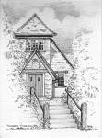

Village halls and other community buildings are the focus for people who live in rural communities and provide a vital local resource for the villages and parishes they serve.

Villages Other Settlements

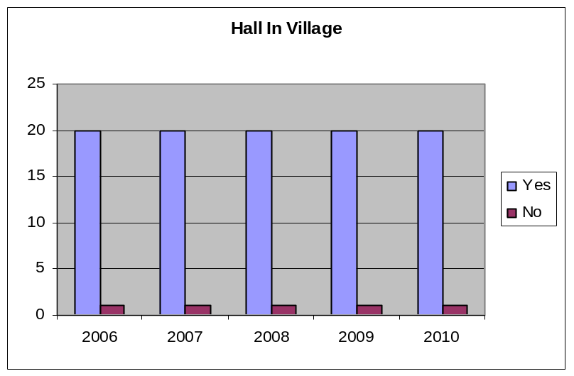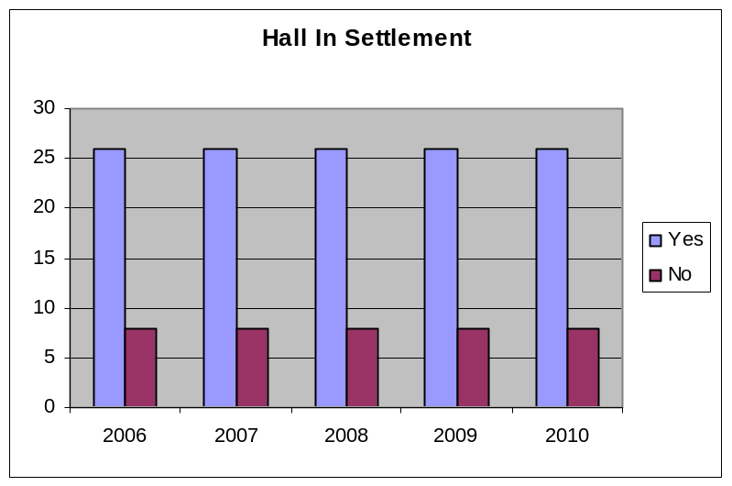

Halls come in many different forms including: memorial halls and halls belonging to churches. It can be seen that only 9 out of the 55 chosen settlements do not have a hall, which indicates the importance of them within the rural community.
Village halls are no longer just a place to meet for social occasions such as parties, wedding receptions, guides and scouts clubs but have blossomed into providing a venue for an impressive range of other activities such as local health facilities, farmers' markets, lunch clubs for older people and IT facilities.
Many settlements have energetic and committed village hall committees, and many projects have stemmed from involving the community, tapping into their talents, time and skills.

9. Post Office 

Post Offices are central to a vibrant and focused local community.

Villages Other Settlements

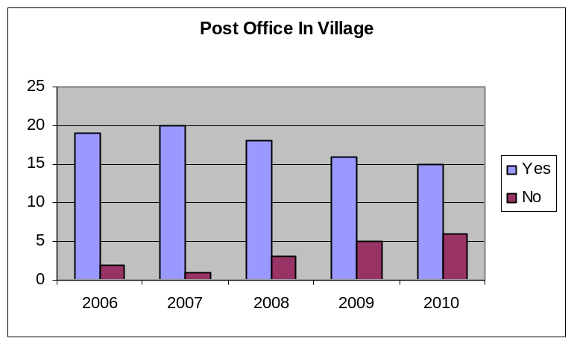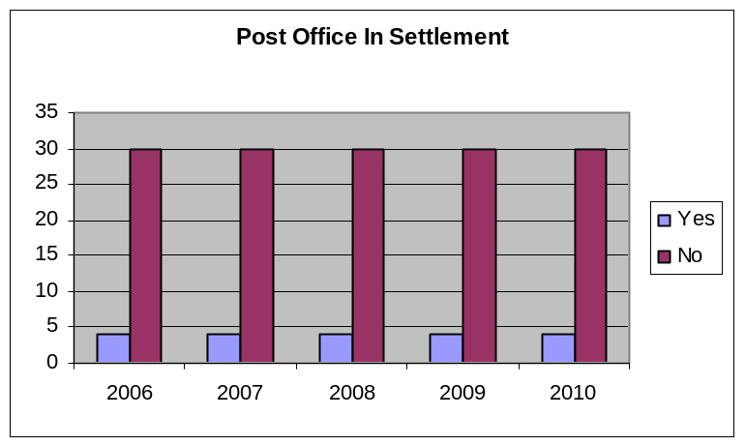

Back in Nov 2004 there were about 8,500 rural post offices in the U.K. Now there are approximately 8000. According to the Post Office almost all rural branches are loss making, and this could be one of the reasons for not only the decline but the fact that a lot of Post Offices are franchised out to e.g. SPAR or Londis. Therefore a lot of rural Post Offices are linked to village stores.
There seems to be no correlation between village/settlement size and whether there is a Post Office e.g. Kennerleigh parish has a total 2009 population estimate of 46 yet it has a thriving Post Office, yet the village of Shobrooke, with a Parish population of 548 does not have a Post Office.

According to the Post Office “94 percent of people live within a mile of a Post Office™ branch “ – however for the smaller settlements surveyed that do not have a Post Office most will fall within the 6% of the population that do not live within a mile, due to the rural nature of the district.

The Post Office has tried to address the issue of rural postal services and rural isolation by creating the “Postbus”. Postbuses pick up passengers as well as post, twice a day, so people in even the remotest towns and villages can get around and keep in touch. Unfortunately there is no such service in the South West.

The Government recently proposed to significantly reduce the provision of branch Post Offices. A whole consultation process across the country was to be implemented over a 12-18 month period starting in October 2007. Post Offices earmarked to close were Crediton (Exeter Road), Bow, Cheriton Fitzpaine, Copplestone, Halberton, Kennerleigh, Newton St Cyres, Oakford and Yeoford. These were to be replaced by limited outreach services ie two mornings, 2 days per week. The outreach service provided was to depend on the individual Post Office’s current usage.

Post Offices that have closed are Crediton (Exeter Road), Bow, Halberton and Yeoford. However since the 2009 survey Chawleigh’s Post Office has also closed along with the village shop. A new purpose built building is currently under construction which will contain a shop and post office facilities.

10. Bus Service 

Having a bus service gives people in rural areas improved access to work, education, healthcare, shopping and recreational activities and by so doing assists in reducing their social isolation. It can also help rural economies provide access to jobs.

Villages Other settlements
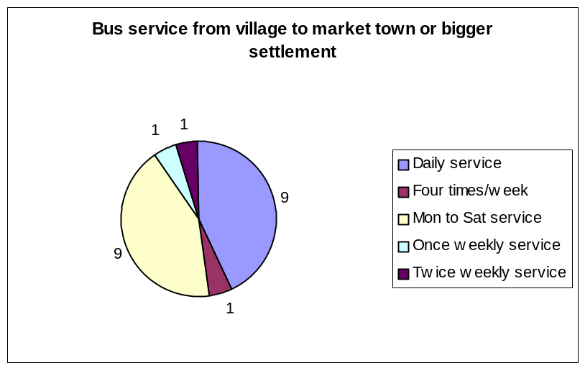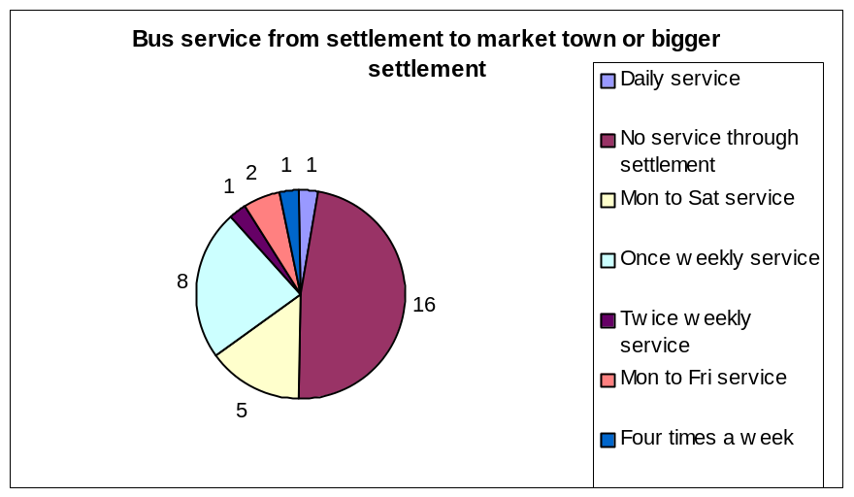

In looking at the bus service it was looked to see if there was a bus to one of the market towns (Tiverton, Cullompton or Crediton) or one of the larger settlements e.g. Exeter, Taunton and the frequency of any such service.

What can often happen is that even if there is a bus service, it is not used to its full potential, and this inevitably leads to its eventual decline.

There have been several initiatives within Devon as a whole to try and combat the issue of rural public transport.

The Devon Rural Transport Partnership (DRTP) was launched in 1999 to investigate and address rural transport issues in Devon. The Partnership is made up of over 30 voluntary, community and statutory agencies that all have an interest in improving access to services within the county.

A Community Bus Scheme operates involving the operation of a small bus by a community-based organisation, utilising volunteer drivers to provide regular, scheduled local bus services planned in response to local needs on a non-profit making basis. They have proved to be an invaluable asset to the more remote and isolated communities where conventional Public Transport cannot meet the identified need in a cost effective manner. There is such a scheme in Mid Devon – the Exe Valley Bus – which operates North of Tiverton

Ring & Ride Schemes also operate within a number of towns and rural locations throughout Devon. They are the main initiative in the provision of public transport for Disabled and Frail Elderly people and provide a local service into local towns to allow potentially house bound people the opportunity to shop and use local amenities.

Three of the villages Lapford, Copplestone and Yeoford are also served by a rail link to either Crediton or Exeter Monday to Sunday.

11. Petrol Station 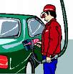

Petrol stations really only serve customers who are moving through an area.

Villages Other Settlements

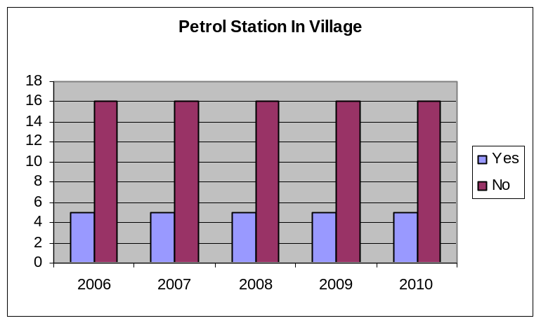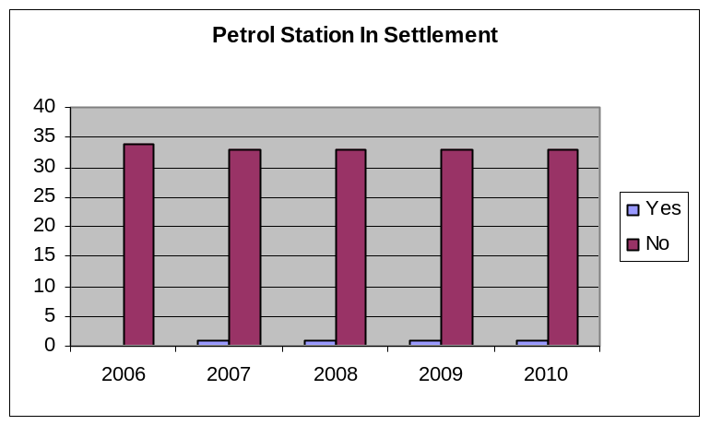

It is not too much of a surprise to see that there were only 6 petrol stations in all of the selected settlements. Three were in settlements with a fairly main road running through it – Lapford (road between Crediton and Barnstaple), Copplestone (road between Crediton and Okehampton) and Willand (Road between Uffculme, Willand and Cullompton)
The other 3 were very much smaller in size and surprisingly 2 of these are only a few miles apart. Previous surveys showed 5 petrol stations, after a site visit in 2007 it was found that Holcombe Rogus has a petrol station within the village.
12. Summary 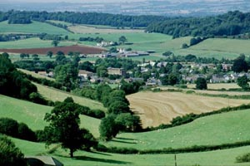

People living in the countryside do so for a number of reasons for example fresh air, wide-open spaces and pace of life. However, isolation can often come at a cost when it comes to access to services that can be taken for granted in towns and cities.
Those that are likely to be disadvantaged are the less affluent, the elderly, those with young children and teenagers who are often at a disadvantage when it comes to something basic like getting to the shops or travelling to work.

Within Mid Devon it can be seen from this report that some areas are better provided for than others.

It is a challenge to provide quality rural services, and there are solutions to the problems for example ‘Pub is the Hub’, however some of the responsibility must be with the large organisations e.g. NHS
The NHS has a number of core principles including: the NHS will respond to the different needs of different populations. Be responsive to the different needs throughout the regions and localities.
It needs to act on this principle for example over the years there has been outward migration of the young and inward migration of the older retired population, therefore bringing with them a whole new set of healthcare issues.

Service decline may not affect everyone within Mid Devon, however it should be remembered that one day you might find yourself in a rural community where there is no longer a shop or a primary school.
Life in rural areas has changed dramatically in recent years as lifestyles and leisure behaviours change. There has been a major reduction in the number of facilities available in small communities therefore action needs to be taken now, by government, local government and local communities in order to save the services and ultimately the sense of community and well being that having these services brings.

Contacts

If you have any questions about this survey please contact:

Janet Crook
Forward Planning & Conservation
Phoenix House
Phoenix Lane
Tiverton
EX16 6PP

Tel: 01884 234360

Email: jcrook@middevon.gov.uk

Annexe – Data used in survey

All information was gathered through a combination of desk based investigation and site visits. Below are the 21 defined villages in alphabetical order followed by the remaining settlements showing services and facilities within them.

Villages

Bow – Doctor, Mobile Library, Primary School, Shop (Londis at Burston), Pub, Hall, and a daily Bus Service.
Bradninch – Branch Doctors Surgery, Mobile Library, Primary School, Shop, Pub, Hall, Post Office (Within Spar shop), and a daily Bus Service.
Burlescombe ( Includes Westleigh) – Mobile Library, Primary School, Pub, Hall, Bus Service four times a week.
Chawleigh – Mobile Library, Pub, Hall and a Monday to Saturday bus service.
Cheriton Bishop – Doctor, Mobile Library, Primary School, Shop, Pub, Hall, Post Office (Within Mace store), and a once weekly Bus Service.
Cheriton Fitzpaine – Doctor, Mobile Library, Primary School, Shop (Within Post Office), Pub, Hall, Post Office, and a Monday to Saturday Bus Service.
Copplestone – Mobile Library, Primary School, Shop, also a Farm Shop, Pub, Post Office (Within stores), Daily Bus Service and a Petrol station.
Culmstock – Mobile Library, Primary School, Shop, Pub, Hall, Monday to Saturday Bus Service and a Petrol Station (Diesel only).
Halberton – Doctor, Mobile Library, Primary School, Farm shop, Pub, Hall, and a Daily Bus Service.
Hemyock – Doctor, Mobile Library, Primary School, Shop (Within Post Office), Pub, Hall, Post Office, a Monday To Saturday Bus Service, and a Petrol Station (Car Garage).
Kentisbeare – Mobile Library, Primary School, Shop and Post Office combined, Pub, Hall, and a Monday to Saturday Bus Service.
Lapford – Mobile Library, Primary School, Shop (Within Post Office) and shop within garage, Pub, Hall, Post Office, Monday to Saturday Bus Service and a Petrol Station.
Morchard Bishop – Branch Doctors Surgery, Mobile Library, Primary School, Shop, Pub, Hall, Post Office (Within stores), and a Monday to Saturday Bus Service.
Newton St Cyres – Mobile Library, Primary School, Shop and Post Office combined, also a Farm Shop, Pub, Hall, and a Daily Bus Service.
Sampford Peverell – Doctor, Mobile Library, Primary School, Shop and Post Office combined, also a Farm Shop, Pub, Hall, and a Daily Bus Service.
Sandford – Mobile Library, Primary School, Shop and Post Office combined, Pub, Hall, and a Monday to Saturday Bus Service.
Silverton – Doctor, Mobile Library, Primary School, Shop, Pub, Hall, Post Office, and a Daily Bus Service.
Thorverton – Doctor, Mobile Library, Primary School, Shop (Bus in Car Park), also a Farm Shop, Pub, Hall, Post Office (mobile unit in car park), and a Monday to Saturday Bus Service.
Uffculme – Doctor, Library, Primary and Secondary Schools, Shop, Pub, Hall, Post Office (Within stores), and a Daily Bus Service.
Willand – Branch Doctors Surgery, Mobile Library, Primary School, Shop, Pub, Hall, Post Office, Daily Bus Service, and three Petrol Stations.
Yeoford – Mobile Library, Primary School, Pub, Hall, and a twice weekly Bus Service.

Settlements

Bickleigh – Mobile Library, Primary School, Pub, Hall, and a Daily Bus Service.
Brushford – No services or facilities.
Butterleigh – Mobile Library, Pub, and Hall.
Cadbury – Mobile Library,and a Monday to Saturday Bus Service.
Cadeleigh – Pub, Hall, and a once weekly Bus Service.
Clayhanger – Mobile library.
Clayhidon – Mobile Library, Pub and a Hall.
Coldridge – Mobile Library, Hall, and a once weekly Bus Service.
Colebrooke – Mobile Library, Hall, and a twice weekly Bus Service.
Cruwys Morchard – Pub (in Pennymoor which is within Cruwys Morchard parish), Hall, and a Monday to Saturday Bus Service.
Down St Mary – Mobile Library, Hall, and a once weekly Bus Service.
Hittisleigh – Hall.
Hockworthy – Mobile Library, Hall, and a once weekly Bus Service.
Holcombe Rogus – Branch Doctors Surgery, Mobile Library, School, Shop and Post Office combined, Pub, Hall, a Four times a week Bus Service, and a Petrol Station.
Huntsham – Mobile Library, Hall, and a once weekly Bus Service.
Kennerleigh – Mobile Library, Shop and Post Office combined, Hall, and a once weekly Bus Service.
Loxbeare – Mobile Library.
Morebath – Mobile Library, Hall, and a Monday to Saturday Bus Service.
Nymet Rowland – Mobile Library, Hall.
Oakford – Mobile Library, Shop and Post Office combined, Pub, and a Hall.
Poughill – Mobile Library, Hall, and a Monday to Friday Bus Service.
Puddington – Mobile Library, Hall, and a Monday to Friday Bus Service.
Shobrooke – Mobile Library, Pub, Hall, and a Monday to Saturday Bus Service.
Stockleigh English – No Services or facilities.
Stockleigh Pomeroy – Mobile Library, Hall, and a Monday to Saturday Bus Service.
Stoodleigh – Mobile Library and a Hall.
Templeton – Hall.
Uplowman – School, Pub, Hall, Post Office, and a once weekly Bus Service.
Upton Hellions – No Services or facilities.
Washfield – Mobile Library and a Hall.
Washford Pyne – No Services or facilities.
Wembworthy – Mobile Library, Pub, and a Hall.
Woolfardisworthy – No Services or facilities.
Zeal Monachorum – Mobile Library, Pub, Hall, and a once weekly Bus Service.

The above information are the findings as at 31st March 2010. Services are changing all the time, if they have changed please contact me on the above contact details and I will endeavour to update the information in the next survey.

